Recovering Identity: Northern Frederick County Cultural Resources Survey
FINAL SURVEY REPORT

December 2024
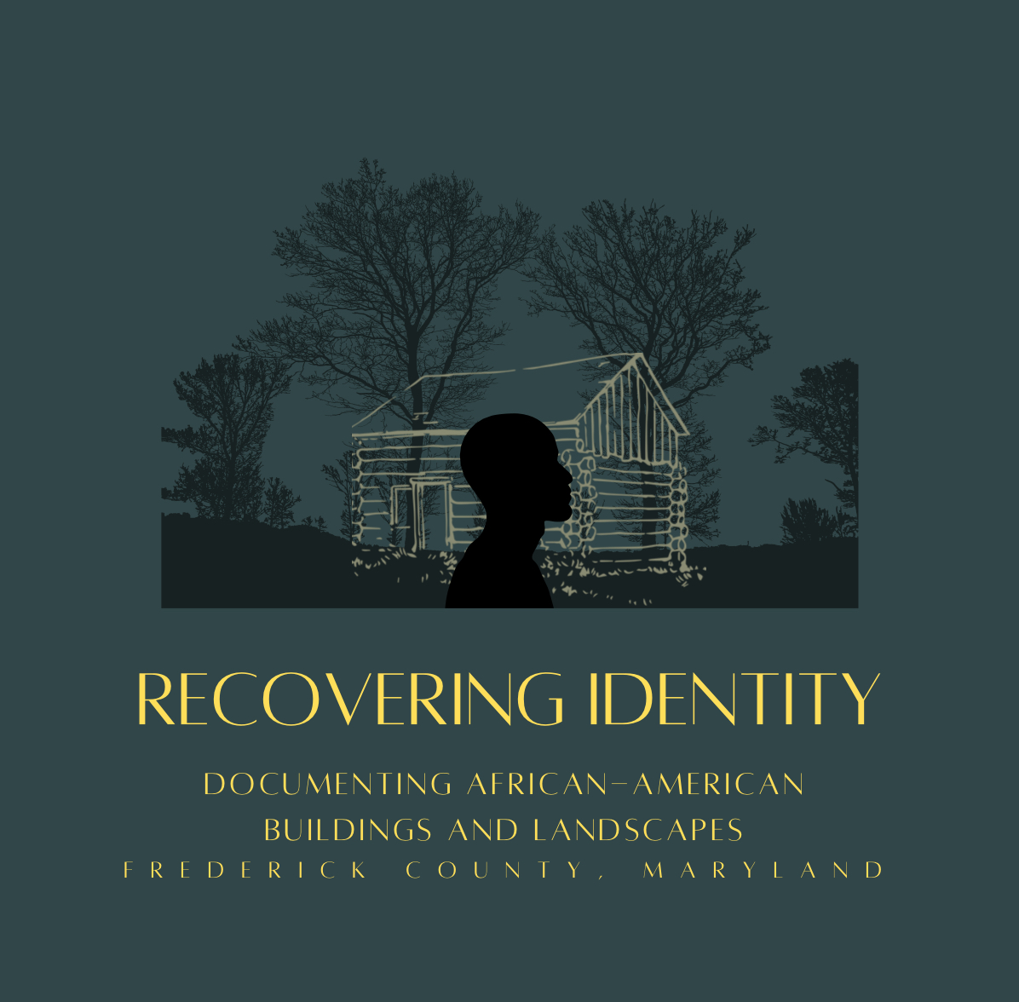

Prepared for  Maryland Historical Trust  100 Community Place  Crownsville, MD 21032 | Prepared by  Elizabeth Anderson Comer  Catoctin Furnace Historical Society  12610 Catoctin Furnace Road  Thurmont, Maryland 21788
Non-Capital Grant Program (FY 2021, Recovering Identity: Cultural Resource Survey)

This Project has been financed in part with State Funds from the Maryland Historical Trust, an instrumentality of the State of Maryland. However, Project contents or opinions do not necessarily reflect the views or policies of the Maryland Historical Trust.

Executive Summary

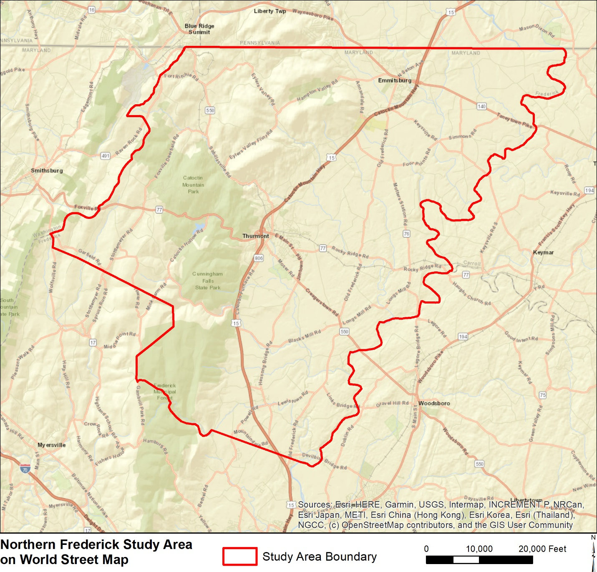
Figure 1: Map of Recovering Identity Project Area

Table of Contents
Acknowledgments
Introduction
Survey Boundaries
Surveyed Properties
Project Team
Research Design (Purpose and Need)
Field Methods
Reconnaissance and Intensive Survey
Archival Research
Historic Context
Results of Field Investigations
Analysis
Public Interpretation and Outreach
Location of Final Products
Summary and Recommendations for Further Research

Acknowledgments
This project was made possible by a $50,000 Maryland Historical Trust (MHT) Non-Capital grant and a $25,000 CLG grant. Additionally, EAC/Archaeology, Inc. and numerous volunteers worked together over a three-year period to complete this comprehensive historic context statement and architecture inventory for African American resources in northern Frederick County, Maryland.

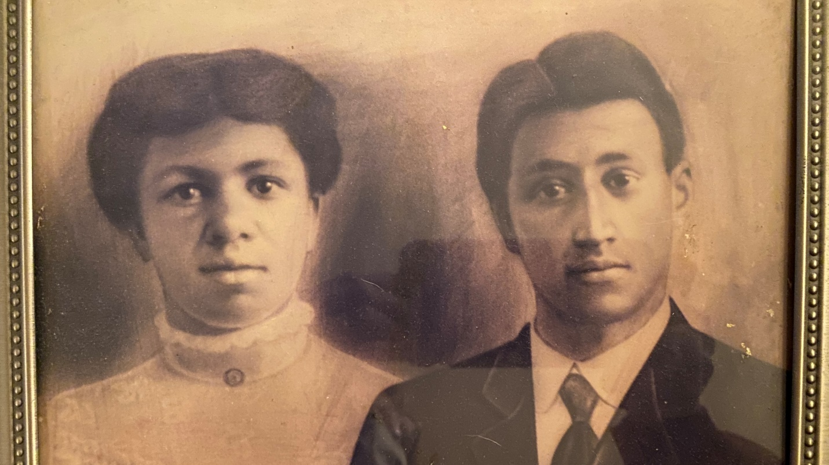
Figure 2: Marie and William “Billy” Richardson, on their wedding day

Introduction
The Catoctin Furnace Historical Society, Inc. (CFHS), together with the African American Resources Cultural and Heritage (AARCH) Society of Frederick County and Frederick County’s Division of Planning and Permitting (FCG) combined a $50,000 Maryland Historical Trust (MHT) Non-Capital grant and a $25,000 CLG grant to complete a comprehensive historic context statement and architecture inventory with an emphasis on previously undocumented African American resources in northern Frederick County. Recovering Identity represents the first documentation of African American resources in northern Frederick County and rediscovered dwellings and landscapes whose African American connection had been forgotten. As will be discussed later, the real cost of this project was exponentially more than the $75,000 grant budget and matching funds.
Called “Recovering Identity: Northern Frederick County Cultural Resource Survey”, the project acknowledged that African Americans have long been left out of historical narratives and their contributions to the development and cultural heritage of not just the County, but the State and Nation. The project was intended to be the beginning of a county-wide effort to identify and survey architectural resources and create an overall historic context statement associated with African Americans throughout Frederick County.

Survey Boundaries
The survey area, based on the boundaries of historic election district boundaries as well as geographic features. Prior to this project, the northern part of Frederick County had never been surveyed for African American resources. Specific project boundaries are the Mason Dixon (Pennsylvania state line) to the north, the Carroll County line as far south as the Monocacy River on the east, the Monocacy River to a point parallel to and including Lewistown on the south, and following the boundary of the greater furnace lands to the west until it intersects with the Washington County line just south of Wolfsville. The boundaries were based on political, historic election districts (which have remained unchanged to the present day), geographic, and socio-economic factors. This area, known as the Monocacy-Catoctin region is inclusive of the historic north-county election districts as they were drawn circa 1880: Emmitsburg District #5, Hauvers District #10, Mechanicstown District #15, Creagerstown District #4, and Lewistown District #20. This delineation made possible subsequent comparisons of population data over time.
Surveyed Properties
21 MIHP forms and the 413-439 West Lincoln Avenue Survey District and NR boundary increase were completed. Additionally, 83 resources were documented as part of the “Memory Landscape” of northern Frederick County African American history.

Project team
Elizabeth Anderson Comer served as the project team director. Edie Wallace completed the comprehensive historic context report with review and input by Alexandra McDougle, an emerging African American scholar as a diversity content reader. This foundational text informed the survey and recordation of MIHP forms by architectural historian John Murphey. Edie Wallace and Elizabeth Comer formulated the memory landscape to capture and preserve the myriad of data that completed the rich African American influence and impact on the north county. Edward Quinter, a renowned scholar of Moravian church records, undertook translation of Graceham diaries and letters written in old German that contained information about African Americans in northern Frederick County.
Supporting this research were numerous volunteers and researchers. In-kind contributions were committed by Elizabeth Anderson Comer, Dr. Rick Smith, Marilyn Veek, and EAC/Archaeology, Inc. staff including Dr. Rob Wanner, Patrick Kim, Meredith Katz, Paula Stoner Reed, Tery Harris, and Ben Fischler. Frederick County HPC staff Amanda Whitmore and Beau Lockard assisted the project, setting up virtual gatherings and providing county support. Heather Barrett and Allison Luthern were essential team members, providing MHT files and surveying expertise. The in-kind support in the form of donated labor included genealogical and African American settlement research donated by Dr. Rick Smith. Dr. Smith had been pursuing African American population research in Frederick County for more than 10 years. He developed a methodology to locate small African American communities that included detailed land deed histories and GIS mapping that resulted in the successful development of extensive 7-8 generation African American genealogies. He brought this expertise to the northern sector of the county where he already had located several gravesites that indicate nearby habitation in Emmitsburg (Mt. St. Mary’s grotto cemetery and at least one house extant), Lewistown (St. John’s church and cemetery), Creagerstown (cemetery) and within the greater furnacelands. More recent research he undertook identified 16 African American blacksmiths in the northern sector within the 19th century. Dr. Smith’s untimely death during the project was a huge loss but his contributions were essential to its success.
Additional donated time and expertise included management, survey, oral history, and research time by Elizabeth Anderson Comer; donated title searches by Marilyn Veek; and donated accommodation at the historic Forgeman’s House from CFHS for John Murphey while he is in the area conducting research and surveying properties. Additionally, Elizabeth Comer agreed to donate the use of state-of-the-art oral history equipment, a flatbed scanner, training for open-source Audacity editing software, and all computer time. Alexandra Krongos, an intern with Frederick County, indexed and catalogued the enormous number of files and related materials collected during the project. Emerging professionals brought onto the team were contributed research and survey time, greatly enhancing the project. These young scholars included Keely Farrell, Kaylie Bergeson, Tamara Pilson, and Dominic Curcio. In particular, Dominic’s dogged pursuit of information about Mt. St. Mary’s University and the role of African Americans on the campus was invaluable.
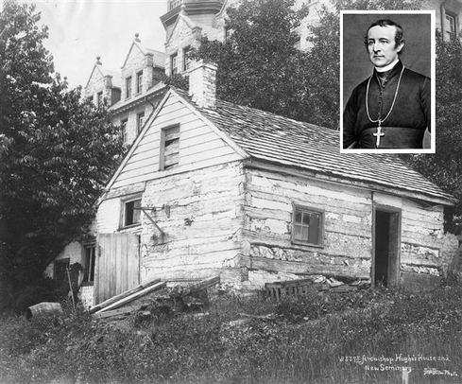
Figure 3: Undated photograph of John Hughes Cabin (F-6-24-1), located by Dominic Curcio at Mount St. Mary’s University, Hugh J. Phillips Library, Special Collections and Archives
Research Design (Purpose and Need)
Extreme developmental pressure on Northern Frederick County, a distinct geographic and socio-economic sector of the county, and a recent uptick in new residents moving to the area in search of lower prices, high quality schools, and available land mean that the "rare window of time" to complete this project was small and closing quickly. As a result of development and a surge in the purchase of smaller historic properties, the shape of the landscape had changed significantly in the past decades, and many of the features important to the African American memory of northern Frederick County had been lost. Further, as the older members of the community, who have a deep well of knowledge, age and die, we were at risk of losing their stories and their critical knowledge forever.
The specific goals of the project included survey to identify and record to the Maryland Inventory of Historic Properties (MIHP) extant structures and cultural landscapes associated with African Americans in the project survey area.
Additionally, the “Recovering Identity” project was meant to identify the best practices, issues, and methods for identifying and recording historic properties associated with African American history so that this protocol can be applied to the remainder of Frederick County.
Outside of Catoctin Furnace, in which at least 271 enslaved and freed African Americans lived and worked between 1776 and the 1840s, little was known about the African American presence in the north county. The goal of the project was to both provide an interpretive framework to recover information about African Americans who lived and worked in the northern sectors of Frederick County and to identify a sampling of building types that have ties to the African American community, focusing on vernacular structures and to find, inventory, and record all previously undocumented African American buildings and landscapes in the project area.
The goals of the project included public outreach to expand the community’s knowledge of cultural resources in the north county and place the African American history of the region into the wider knowledge base and understanding of Frederick County and its history. It was hoped that this would in turn lead to a better understanding of the area’s array of African American architectural and landscape features. Further, the project was designed to draw attention to structures and sites neglected in historic preservation efforts in northern Frederick County. The project directly aligned with the 2018 Maryland Historic Preservation Plan’s goals of #1) connecting with a broader audience, #3) expanding and updating documentation, and #4), building capacity, and strengthening networks.

Figure 4:

Field Methods
The project was scheduled to extend over a two-year period, from 2021 through 2023 although final documentation continued into early 2025. The extended timeframe of the project reflects the difficulties encountered. The project was structured to meet the various requirements and deadlines of the two grants. The CLG grant had a firm one-year timeline and limited product scope of work to survey and produce 10 MIHP forms and support the ongoing Moravian diary and letter translation project. The MHT non-capital grant, with a longer timeline and broader scope of work to complete the comprehensive historic context report, undertake additional Moravian diary translation, and complete 10 additional architectural survey with MIHP form recordation, was underway simultaneously and the two grants were dovetailed in their product and execution.
Rapid development and loss of historic resources made this project and its timing of paramount importance. In addition to the loss of buildings associated with African American history, the team quickly found that other buildings associated with African American history that remain had been highly modified. Finally, historic buildings associated with African American history were occasionally owned by whites, creating difficulties in the paper trail that relies on property ownership as opposed to residency. To fully document and understand the African American history of northern Frederick County, the team developed a Memory Landscape that recorded and preserved disappeared aspects of African Americans in the north county. This memory landscape recordation was undertaken to supplement the completion of MIHP forms, without which a full understanding of the scope and breath of African American influence in northern Frederick County would be impossible.
Project community outreach included exhaustive door-to-door visits and oral history recording as well as a daylong seminar and tour of the project area in April 2024. Finally, the enormous metadata compiled during the project has been catalogued and organized for use by future researchers and is available on the CFHS website.
Prior to the Recovering Identity project, no research had been undertaken for the purpose of locating African American resources in northern Frederick County. This project filled that gap in knowledge by completing a comprehensive historic context statement for northern Frederick County, with an emphasis on African American history, as well as documenting extant structures with completion of MIHP forms. Additionally, a memory landscape of disappeared African American resources was compiled. Unanticipated within the project scope of work, the Recovering Identity project also resulted in the expansion of the Emmitsburg National Register Historic District (F-6-102) to include the African American structures along Lincoln Avenue.
The team gathered to undertake the project included historians, archaeologists, a critical content reader, emerging professionals, an architectural historian, and multiple volunteers conducting title searches and historical research. These volunteers and scholars funded by the grants were supported by staff from EAC/Archaeology, Inc. Once formed, the team began meeting virtually in early 2021 after a project commencement in November 2020.
The team carefully choose the boundaries of the northern sector of the county: the Mason Dixon (Pennsylvania state line) to the north, the Carroll County line as far south as the Monocacy River on the east, the Monocacy River to a point parallel to and including Lewistown on the south, and following the boundary of the greater furnace lands to the west until it intersects with the Washington County line just south of Wolfsville. The boundaries are based on political, historic election districts (which have remained unchanged to the present day), geographic, and socio-economic factors. This area, known as the Monocacy-Catoctin region is inclusive of the historic north-county election districts as they were drawn circa 1880: Emmitsburg District #5, Hauvers District #10, Mechanicstown District #15, Creagerstown District #4, and Lewistown District #20. This delineation made possible subsequent comparisons of population data over time.
Recognizing that the most important first step in informing the community and gathering information was community participation and gathering informants, the team planned outreach sessions to introduce the project. The effects of the pandemic necessitated virtual gatherings. The first was a public forum held on May 24, 2021at 7 pm, sponsored by Frederick County on their public meetings platform (virtual) to engage the community. This gathering as well as several subsequent forums slated to focus on African American communities in Lewistown, Emmitsburg, Catoctin Furnace, Creagerstown, and other heretofore unidentified communities of African Americans in the north county proved less than successful with limited public engagement. The team realized that, notwithstanding pandemic limitations, the survey needed to be hands-on and personal. Project director, Elizabeth Comer, began going door to door throughout the project area to confirm locations, speak with owners and/or residents, gather local knowledge and oral histories, gather photographic documentation of structures and landscapes in advance of the formal architectural survey. Sitting at kitchen tables, standing in open doorways, leaving a letter of introduction and returning a week or so later, leafing through photograph albums, and gaining trust with each passing month was essential to slowly peeling away the layers of obfuscation that veiled the rich African American heritage of the area. Only once in more than 3 years was a property owner unwilling to help.
This documentation of current conditions proved particularly informative as modifications to the historic structures were of paramount importance in determining the extant African American integrity of resources. Concurrently, the GIS and mapping experts, Dr. Rob Wanner and Patrick Kim, compared historic maps to modern topos to identify structures that were extant. Additionally, the team title searcher, Marilyn Veek, began running title searches on structures to identity African American ownership. Identifying African American rental properties was more difficult but the team used historic maps and census records to pinpoint places of interest.
The comprehensive historic context framed specific questions to be explored. For example, of particular interest was the transition of the workforce in and around Catoctin Furnace from enslaved and freed African Americans to European immigrant populations. Economic pressures including the panics of the 19th century and resultant bankruptcies and sale of enslaved persons were a particular line of inquiry within the context statement. Questions such as how did the populations change and transition from primarily African American to primarily European American with transition periods of mixed workforce demographics in northern Frederick County? How did these mixed populations function? While the northern county was the overall focus of the context statement, it was recognized that the industrial center of Catoctin Furnace had significant influence socially, economically, and environmentally within the north county. It also had significant research resources compiled by the Catoctin Furnace Historical Society during its 52-year history. The completed historic context report developed the history of African Americans in northern Frederick County through the lens of the social, economic, and environmental influence of Catoctin Furnace as the industrial center of the region. Significant within this industrial theme is the use and sale of enslaved persons during economic turmoil and the transition of the workforce in and around Catoctin Furnace from enslaved and free African Americans to European immigrants. A parallel thematic development was the agricultural landscape of the region, settled by a largely Catholic population. The role of the Catholic Church in the lives of enslaved and free African Americans is integral to the northern Frederick County story, drawing on the history of Mount St. Mary’s University and St. Joseph’s Academy.

Project Director Elizabeth Comer previously identified the Moravian diaries as a source of information about African Americans in the north county recorded by ministers at Graceham Moravian Church beginning in 1758. Written in German, these diaries and letters located at the Moravian Archives in Bethlehem, Pennsylvania, were thought to contain enormous potential data about African Americans in Northern Frederick County that could help identify structures associated with African Americans for MIHP form completion as well as provide valuable data for the historic context report. Previously untapped, this resource of more than 100 diaries and church minutes extended through the 19th century. The Moravian ministers were tasked with ministering to the community so they would ride throughout the northern part of Frederick County from Monocacy and later Graceham and describe their activities. This included baptisms, marriages, funerals, etc. The diaries and letters also contain detailed descriptions of enslaved work and home life. The records had neither been digitized nor translated from old German. Translation was undertaken by Edward Quinter, a noted Moravian researcher fluent in old German. His rate was $60.00 per hour, and it was estimated that each diary would cost approximately $500. Using the years from 1760 – 1860 when enslaved would be in the area, the full cost would be $50,000. We pared back the transcription to focus on key words such as iron, slave, Catoctin, sickness, birth, death, burials, weather, and all names. This allowed for the translation of as many years as possible beginning in 1766 and continuing until 1859. The entries helped create a fuller picture of life in northern Frederick County in the 18th and 19th centuries and provided data about names and relationships of the enslaved and free African Americans as well as buildings and locations within the landscape that reflect the presence of the enslaved and freed of northern Frederick County.

Reconnaissance and Intensive Survey
Survey research began with a history of landownership and use based on archival research as well as hours of driving the roads of northern Frederick County in search of structures seen on historic maps and historic aerial photographs. A spatial analysis of LiDAR data to map archaeological topography and small-scale features was undertaken. Oral histories were collected, and historic photo collections consulted. Thus, the identification of architectural resources to be surveyed and documented was based on local input, maps and aerial photography, known locations, and reconnaissance survey. The identification and recordation employed methodology based on procedures outlined in “Standards and Guidelines for Architectural and Historical Investigations in Maryland” and guidance from the NPS’s “Guidelines for Local Surveys.” Structures identified during the survey were fully recorded with MIHP forms.
In addition to Catoctin Furnace which represents the largest concentration of African Americans in northern Frederick County prior to the Civil War, locations of African American enclaves which were quickly apparent included Emmitsburg (including Poplar Ridge, Mountain Community, Mount St. Mary’s, and St. Joseph’s Academy), Lewistown, Utica, and Creagerstown. However, to manage the need to complete 10 MIHP forms within the first year of the two-year project, the team initially focused on three enclaves: Emmitsburg, Lewistown, and Pattersonville. Within these locales, extant structures owned by African Americans were researched, such as those found along Annandale Road, Crystal Fountain Road, and Lincoln Avenue in Emmitsburg; structures on Hessong Bridge Road and Powell Road in Lewistown; and buildings on Catoctin Hollow Road, within the 11,894-acre greater furnacelands of Catoctin Furnace. For example, research about the population of Catoctin Furnace demonstrated that the wider "village" extended up the mountain into an area of freed African American homes and a “colored” school in the late nineteenth century.

Archival Research
Detailed research to produce both the historic context, the MIHP forms, and the memory landscape utilized all available historical records and secondary sources, as well as oral histories, historic maps, genealogical data, gravesite information, Moravian Diaries transcriptions, and census databases. Histories of land ownership and use of private holdings were compiled using records at CFHS, AARCH, Cunningham Falls State Park, and Catoctin Mountain Park. Repositories consulted included Mount St. Mary’s University archives, Daughters of Charity Provincial Archives, Maryland State Archives, Episcopal Diocese of Maryland Archives, National Archives, Library of Congress, Maryland Room (C. Burr Artz Library), Maryland Historical Trust library files, historic newspapers, church records, local historical society records, records of the Works Progress Administration, records of the Civilian Conservation Corps at the FDR Presidential Library, and reports from Catoctin Mountain Park (NPS). Research methods followed procedures outlined in Standards and Guidelines for Architectural and Historical Investigations in Maryland as well as input from the community.

Figure 7: Wolfe House (F-3-290)
Historic Context
The context begins with the cultural landscape as it appeared prior to European and – by extension through enslavement – African settlement, covering the prehistoric and precontact Native American occupation and their early contacts with explorers and traders. Woven into this is the story of enslaved freedom-seekers who found asylum in Maryland’s western mountains among the Native Americans living there in the 1720s. It continues through the 18th and 19th centuries, tracing the growth of the Catoctin Furnace iron manufacturing complex and the surrounding agricultural landscape and the use of enslaved Black laborers as well as free Black labor. This period also includes the national context of the Revolutionary War, the meaning of American freedom, and its impact on slavery in the region, including paths to freedom through manumissions, freedom-seekers, and the Underground RR. Enclaves of free Black households are identified in various areas of the survey area, with discussion of employment, housing, and landownership. The Civil War period includes discussion of the national context of the war, and encompasses emancipation in Maryland in 1864 and local African American enlistments in the Union army. The post-war period focuses on the growth of Black communities amid segregation, using Freedmen’s Bureau records, census records, land records, local histories, and oral interviews to develop a picture of the African American cultural landscape into the 20th century. The report concludes with the mid-century Brown v. Board Supreme Court decision that began the process of integration, the Civil Rights movement of the 1960s, the Ku Klux Klan revival in Rocky Ridge, and consideration of today’s social justice movement. Throughout the text, individuals and associated buildings and landscapes are identified to aid in the identification of potential MIHP survey properties and the comprehensive Memory Landscape appendix.

Results of Field Investigations
21 MIHP forms and the 413-439 West Lincoln Avenue Survey District and NR boundary increase were completed:
John Sanders Sr. House located at 10513 Lenhart Road, Frederick - MIHP: F-3-289
Wolfe House located at 10918 Powell Road, Thurmont – MIHP: F-3-290
Eli and Mae Wolfe House located at 10844 Powell Road, Thurmont - MIHP: F-3-313
Holliday-Snow House located at 11024 Powell Road, Thurmont – MIHP: F-3-291
Ephraim Richardson House located at 11027 Powell Road, Thurmont – MIHP: F-3-97 – Addendum
Hettie Parker and Gertrude Downey House located at 810 West Main Street, Emmitsburg – MIHP: F-6-102-2
David and Harriet Hill House located at 812 West Main Street, Emmitsburg - MIHP: F-6-102-1
George W. Abey Tenant House located at 814 West Main Street, Emmitsburg – MIHP: F-6-162
Charles Lee Sr. House located at 16732A Annandale Road, Emmitsburg – MIHP: F-6-155
Mountain Community Log House located at 16720 Annandale Road, Emmitsburg – MIHP: F-6-156
Martin Lee House located at 16731 Annandale Road, Emmitsburg - MIHP: F-6-157
Patterson-Willard House located at 13501 Catoctin Hollow Road, Thurmont – MIHP: F-6-158
Hauver-Patterson House located at 13620 [13630] Catoctin Hollow Road, Thurmont - MIHP: F-6-160
Henry Williams Property located at 119-121 Water Street, Thurmont – MIHP:F-6-163
Implements Building located at National Shrine of Saint Elizabeth Ann Seton (no street address), Emmitsburg - MIHP: F-6-20-1
John Hughes Cabin located at 16330 Grotto Road, Emmitsburg - MIHP: F-6-24-1
“Spirit of the American Doughboy” located at 601 West Main Street, Emmitsburg – MIHP: F-6-103
St. Euphemia’s School and Sisters’ House located at 50 DePaul Street, Emmitsburg – MIHP: F-6-41
Hampton Furnace Site Stone House located at 8825B Hampton Valley Road, Emmitsburg – MIHP: F-6-164

Added by EAC/Archaeology, Inc.
Weller-Johnson House located at 27 W Main Street, Thurmont – MIHP: F-6-114

Added by John Murphey and Elizabeth Comer
Auburn located at 12320 Auburn Road, Thurmont – MIHP (delivery of this form with MHT in 2025)

West Lincoln Avenue (Boundary Increase to the Emmitsburg Historic District)
West Lincoln Avenue Survey District, 413 – 439 West Lincoln Avenue, Emmitsburg – MIHP Amendment: F-6-102-3
Emmitsburg Historic District (Additional Documentation and Boundary Increase), Emmitsburg:
NRHP 92000076
Created by JWM, November 15, 2024

One particular victory was approval on April 8, 2024 of the boundary increase and additional documentation for the Emmitsburg Historic District to include the African American structures along Lincoln Avenue: NRHP 92000076:
MARYLAND, FREDERICK COUNTY,
Emmitsburg Historic District (Boundary Increase),
A portion of the south side of the 400 block of West Lincoln Avenue, from Patterson Avenue, 375’ west, to the west property line of 439 West Lincoln Avenue,
Emmitsburg, BC100010150,
BOUNDARY INCREASE APPROVED, 4/8/2024

MARYLAND, FREDERICK COUNTY,
Emmitsburg Historic District (Additional Documentation),
Roughly, Main St. E of Mountain View Cemetery to Creamery Rd. and Seton Ave. adjacent to Main,
Emmitsburg, AD92000076,
ADDITIONAL DOCUMENTATION APPROVED, 4/8/2024

Analysis
The considerable challenge encountered with the merging of the two grants and the firm CLG deadline was the requirement of the CLG to produce 10 survey forms before the completion of the comprehensive context report and prior to the completion of related detailed historical research such as the translation of the Moravian diaries, only a small part of which was supported by the CLG grant.
Throughout 2021, 2022, and 2023 the team continued the research and survey work. A major disappointment occurred when the initial MHT staff visit occurred and the issue of lack of integrity was revealed. Many structures identified as African American were denied MIHP documentation due to changes undertaken by subsequent non-African American owners. This pattern repeated itself over and over and was emblematic of the loss of the African American population within the north county. Had the changes been made during ongoing African American ownership, the structures would have been considered worthy of MIHP recordation. With non-African American ownership, this integrity was lost.
In order to ensure that these data were not lost, Elizabeth Comer formulated the concept of a memory landscape and together with Edie Wallace, incorporated it into an appendix of the historic context report. It is a list of 83 known buildings, structures, sites, etc. that are documented or are believed to have historic African American associations. While this list is undoubtedly incomplete, it demonstrates a pattern of African American displacement from the region beginning around the turn of the twentieth century. Many buildings and structures associated with African Americans in the northern districts have been demolished or significantly altered since that time by subsequent white owner/occupants. Now documented within the Memory Landscape, they provide a rich tapestry of lives knowable to their descendants and area residents and researchers.
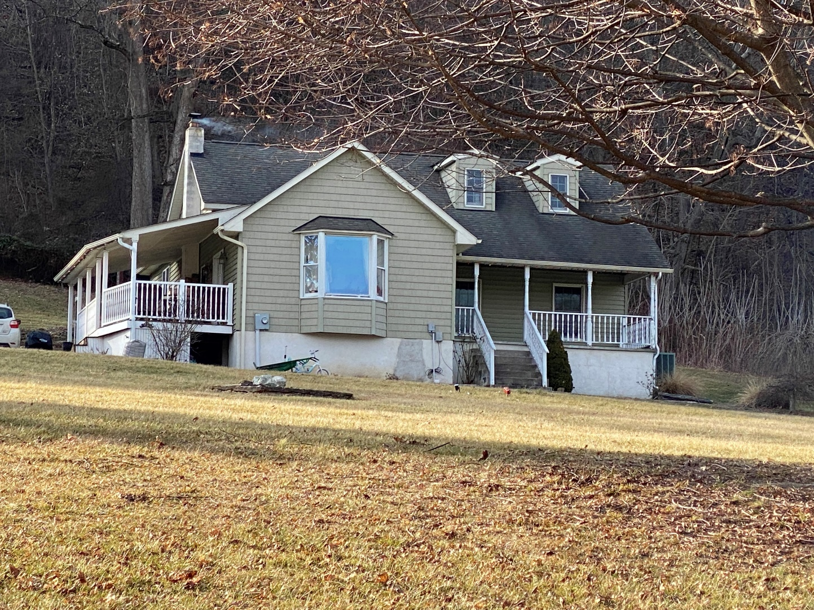
Figure 6: Abraham Lee House. The original small circa 1844 log cabin likely remains within the existing house, greatly altered with several additions.

Public Interpretation and Outreach:
Throughout the project, regular presentations were made to keep the public informed about progress.
On May 24, 2021, members of the team introduced the project during the initial virtual town hall type meeting broadcast on the county channel.
On February 26, 2022, Elizabeth Comer presented an overview of the project, its goals and progress during the Frederick Historic Sites Consortium Master Docent program.
On September 27, 2023, Elizabeth Comer provided an update on the project at the kickoff for the next phase of the countywide Recovering Identity project.
On Saturday, April 27, 2024, the project held a daylong seminar and bus tour of identified north county sites. The morning seminar at the Thurmont Regional Library was free and was attended by 87. Box lunches were available for purchase and the bus tour followed from 105 pm. CFHS reserved that 40 passenger bus and asked guests to pay $15.00 if possible to defray the $1,240 cost of the bus and driver.
On July 11, 2024, Edie Wallace presented the results of the survey at the 2021 MHT Non-Capital and Certified Local Government Grants Documenting Underrepresented Communities: Presentations and a Roundtable Discussion" forum. Elizabeth Comer was unable to be present due to Covid19.

Location of final products
The enormous body of materials collected during this three year project have been catalogued and indexed. The metadata will be accessible on CFHS website as well as at the Maryland Room and AARCH.
All MIHP forms, the historic context report, and this project summary are available on the CFHS website and the Maryland Historical Trust website.
The NR Boundary Increase Documentation is available on the Maryland Historical Trust website, the CFHS website, and the National Register of Historic Places website.

Summary and Recommendations for Further Research
While the team attempted to turn over every stone, there is much work to be done. And while this project took additional time and funding (donated) beyond that anticipated, it still should be used as a model to be replicated in other parts of Frederick County and throughout Maryland.
It is hoped that subsequent years will find this methodology, combining public and private research and planning expertise, replicated by the planning department, AARCH, and potentially other historical societies to complete comprehensive survey work and historic context statements regarding African Americans throughout Frederick County.
There were many loose ends of this ever evolving research project that can be followed up by future researchers. For example, Robert (Bobby) Black of Black’s Orchard recounted information from his father that a Black man lived up above the orchard. Elizabeth visited the site (Lat 39.659660 Long -77.400683 with Bobby but could find no trace of a dwelling. It was located off the bend in a private driveway that rises to the west of Kelbaugh Road between Thurmont and Emmitsburg.
Additional research about the African Americans at Mt. St. Mary’s College (now university) could follow up on memories that the cooks there were Black and that they lived on campus. The last names of Williams and Fisher were remembered as cooks.
A grandmother lived on DuPaul Street in Emmitsburg. We tried to locate this but were unsuccessful.
More research about the sewing factory at 719 West Main Street in Emmitsburg should be undertaken. The structure has been demolished but there is oral history that links the structure to an earlier use as a canning factory. Since it is near the African American enclaves on the west side of Emmitsburg on West Lincoln Avenue and West Main Street, was this a work place for African Americans?
Blacks working at the canning factory is another avenue of research. The connection with Belle Glade in Florida should be followed up quickly while individuals who came up to the canning factories are still alive and remember Thurmont and Emmitsburg (was the Emmitsburg factory really gone by the 1940s-1950s?) canning factories (as well as others in Walkersville and lower Frederick County).
The current owner of 16530 Eyler Valley Road, Slim Harrison, asked us to look at a stone outbuilding on his property because he was told that it and Sunshine Trail which runs next to the property had an association with the Underground Railroad. This is definitely a property to research further. There is a graveyard on the property as well that has not been documented.
The legend of a silver mine (the Hager mine) is an open question. After visiting the mine site with a local informant (Gary Willard) who remembers being able to crawl into the open mine shaft as a child, it is clear to the 2 archaeologists that it is a mine. How early and for what product are questions that could only be answered during an archaeological investigation. What is clear is that the mine shaft has collapsed. Is it the very early mine mentioned as being mined by African Americans who were blindfolded going to and from the mine so that they could not relocate it? Mr. Willard said that the Hager mine story was told for years to bring tourists to the area. Located on DNR land within Cunningham Falls State Park, this site was reached after a long and difficult walk from the Patterson House site off Catoctin Hollow Road.
Another unanswered question concerns the outhouse at Catoctin Hollow Road. Dr. Rick Smith was told that the extant outhouse (used now for storage) contained names written on the inside walls while the colored school was in use. The former location of the school is now a garden area and the outhouse may have been moved as it is on the opposite side of the log dwelling but at any rate, this should be followed up on as it might contain names of Pattersons and other pupils. Elizabeth visited the site many times but was unable to gain access. The owner wanted to move items out of the outhouse before allowing anyone to go in and look.
One example of the effectiveness of this multi-faceted research approach is the inclusion of Moravian records. Descriptions of the enslaved at Catoctin in these two passages transcribed from the Moravian records are indicative of the potential for other research projects:
1) The role of slave labor as an integral part of the iron operation is described in the diary of John Frederick Schlegel, minister to the Graceham Moravian congregation. Writing of his activities of July 30, 1799, Brother Schlegel said that he paid a visit to James Johnson, his brother(s), and sons. He particularly visited with the "poor Negroes" at the furnace whom he described as being inwardly and outwardly troubled by their conditions. They gathered around him at the furnace stack weeping at his words of comfort. They told him that they had to work seven days a week in the iron smelter (furnace) and seldom could hear the Word of God. As he finished talking to them, "the signal was given for the pour," and each of them had to be back at work.
2) In 1827, when Moravian clergymen started holding services at Catoctin, they regularly found Black people as well as whites in their congregation. They also visited and ministered to African Americans in their homes. One of the greatest sources of joy to the Moravians was the opportunity to bring divine guidance to Black individuals who were described as being in the majority among furnace workers and had no other chance to hear the Gospel. Some of these people must have been elderly because they are described as having iron-grey hair.
The preparation of a comprehensive historic context report to inform the survey project was essential. It was difficult to begin survey while the context was still being compiled but this scheduling issue was unavoidable given the requirements of the CLG grant. The comprehensive historic context informed the overall understanding of the north county and also identified specific addresses where African Americans lived such as the two log structures on Water Street in Thurmont. This is just one example of a lead for survey that resulted in two MIHP forms that originated with the historic context report research.
Victories such as the identification of 119-121 Water Street in Thurmont was amazing. And finding the Shern family, direct descendants of the builder, Henry Williams was fantastic. The family had lost the connection to northern Frederick County altogether and was absolutely thrilled to find it. The current owner of 121 Water Street (Jigs and Darlene) was a retired construction expert and was thrilled to show us the dwelling and helped deconstruct the myriad changes that had taken place. A document in the collection of the Thurmont Historical Society is entitled “Year of the oldest house on Water Street” and lists 50 street addresses with a name and date associated. The oldest date is 1875 at 24 Water Street and the newest is 1990 at 132 Water Street. What is truly remarkable is that the actual two oldest houses on Water Street, 119 and 121 aren’t even listed (maybe there is a second page that is missing?).
The discovery of a connection between Hayland (now the farm of Charles Kolb) on Blacks Mill Road (formerly Featherbed Lane) just east of Catoctin Furnace and the toddler whose DNA was the first linked in the joint Smithsonian/Harvard University/Catoctin Furnace project proved critical to a deeper understanding not only of the toddler’s family then and now, but also to the ways in which that family moved (or was moved) through time and space. Hanson Summers’, her half brother or first cousin, was enslaved with his parents at Hayland and then at Rose Hill in Frederick, then back at Catoctin, and ultimately at Antietam Ironworks, their last enslaved position before freedom. The hours spent meeting Mr. Kolb’s prized chickens (and learning the name of each), is an example of this deep local knowledge gained only through repeated visits and the slow and steady earning of trust. Are the logs from the 22 room log mansion that was Haylands manor house really in the barn of Highland, located on Black’s Mill Road closer to Whilhide Road? A lead to be followed up as they could provide a dendrochronology date for Haylands as well as tangible materials likely felled and hewed by enslaved hands.
Probably my favorite story (and it is difficult to choose one) is the conversation I had with Willie Van Brakle when he told me about desegregating the Gem Cinema in Emmitsburg. Told to sit in the rear and not with his friends, Willie said no and that was the end of segregation at the Gem in Emmitsburg. What an amazing story and one that speaks volumes to the power of one young boy.
The nature of this work is that there were many, many dead ends. For example, tracing Miss Hannah Hammond was a challenge with huge disappointments again in again. For example, the (now) Kurtz home at 24 Summit Avenue seemed to be the dwelling of Miss Hannah and was even documented for an MIHP form only to be unended by new research that seemed to definitely document a fire that destroyed the home and was replaced with the current ca. 1935 bungalow. Conversations with Dot Tresselt Victor in California as well as her sister Dru Tresselt in Thurmont provided information about Miss Hannah and her continued presence in Thurmont, including the hint that she may have stay for awhile behind Dr. Gray’s house in the (now garage) that has a chimney and bathroom. Complicated by the fact that Dr. Gray’s sister definitely lived in the small 12 x 30 structure for a time, the question of a tangible space occupied by Miss Hannah remains open. Another lead, that of Miss Hannah’s time at the Gaver Household on West Main Street hit a dead end when it was found that the Gaver dwelling was apparently demolished to make way for the off ramp for Route 15. A possible lead to this was Sterling Bollinger, the last owner of the property who might have been able to identify it to the Gavers, died a decade ago.
The relentless, highly detailed, and time-consuming research and survey undertaken for Recovering Identity has resulted in a literal rewriting of the history of northern Frederick County. No longer is the African American history of the area unknown. The reveals that occurred have transformed public knowledge about the north county. No longer is the prevailing narrative that it has been largely devoid of African American residents.

